**How To Upload CSV File AND Create Bulk Of Pages**

**FIRST STEP**

1. Login into wp-admin by using above credential --> Go to All pages and check total  number of pages.

**SECOND  STEP**

**Process of uploading csv files:**

Steps

1. There is a page "**csv.php**", used to upload the csv file.

File path: **broker\csv.php.**

2. You need to copy the URL and paste into browser address bar.(First read the below points) and then hit the enter key.

URL :**<http://example.com/csv.php>**

**Sample CSV file is attached in mail. You can upload it or you can use your own CSV file.**

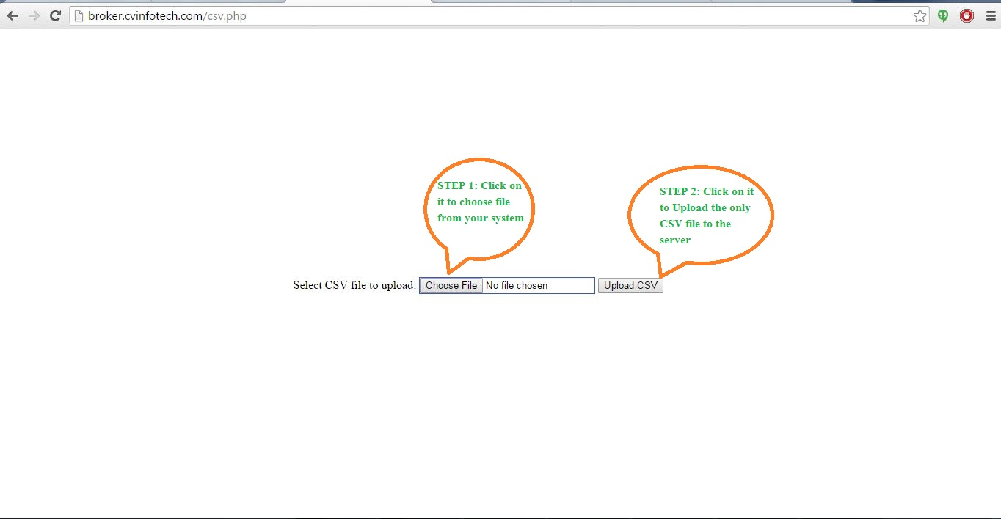**NOTE: Keep the same file structure of CSV file as given in sample files i.e you need to use same field name for your own CSV file as mention in Sample Csv file.**

This page shows after the clicking enter on above link. Read the message in screenshot and go ahead.

**Process of Broker Upload:**

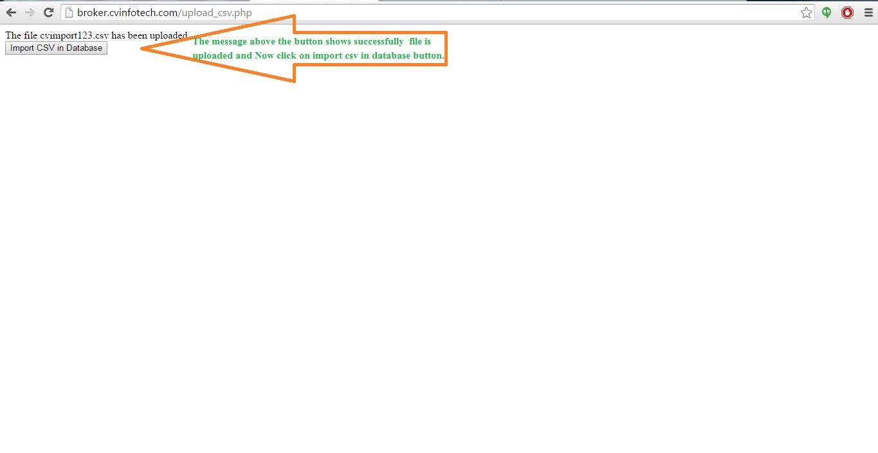

**Success Message of Broker upload:**

**Again follow the direction given in screenshot and go ahead.**

**SECOND  STEP**

**Process of Bulk Page creation:**

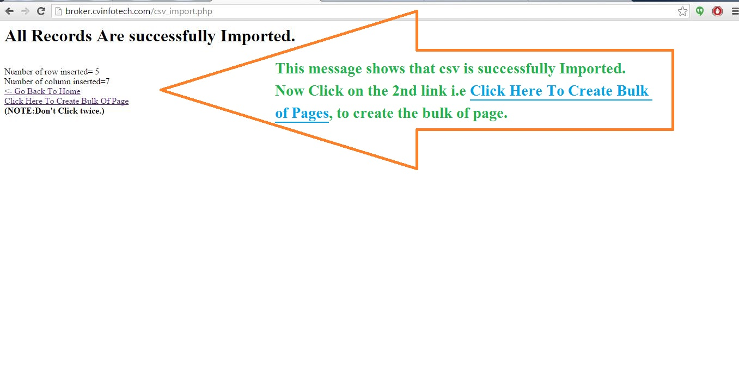

**Success Message Page Creation:**

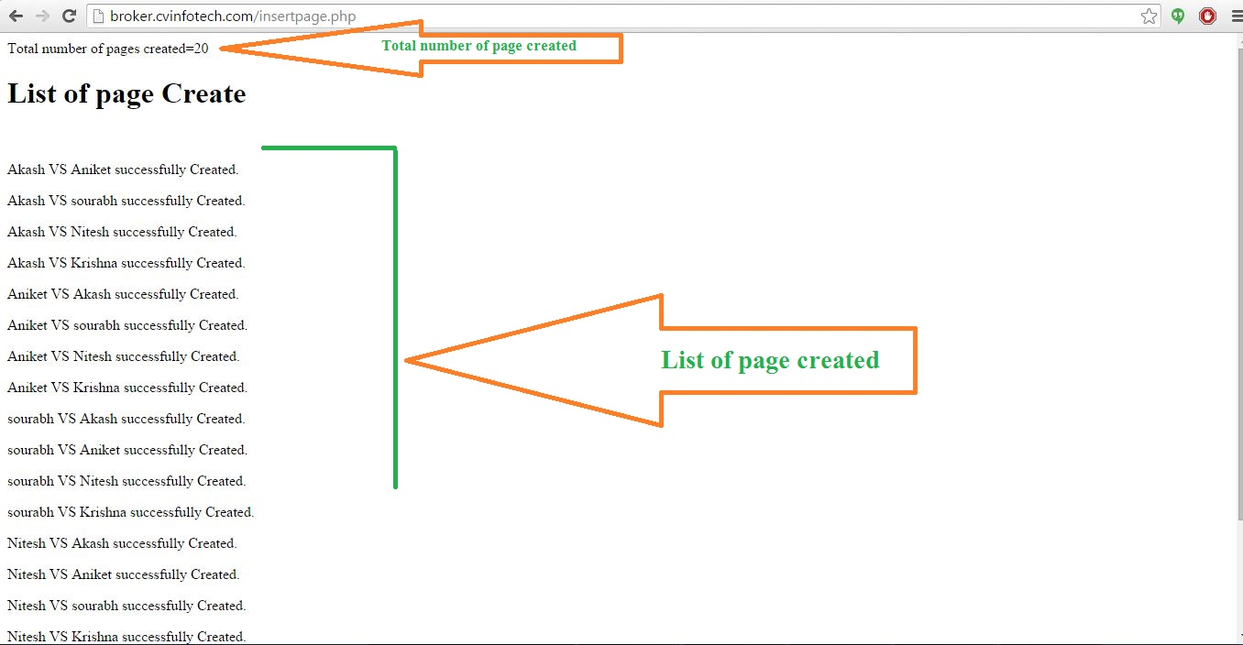

**LAST STEP**

1. Again Login into wp-admin by using above credential --> Go to All pages and check total  number of pages.
2. Click on view option for viewing the new page created.

**#Only css part is left and I’am working on it.**